**PREREQUISTES**

1. Download a linux subsystem on your windows machine. You can follow guide to do it. <https://docs.microsoft.com/en-us/windows/wsl/install-win10#install-your-linux-distribution-of-choice>. I used Ubuntu 180.4 LTS but the rest should work fine.
2. An AWS account. Create one if you don’t have it.

**HOSTING ON AWS LAMBDA**

1. Clone this repo <https://github.com/ManivannanMurugavel/selenium-python-aws-lambda> and store in whatever directory you want. You can delete the zip folder.
2. Replace/edit the code in inside the **lambda_handler** function (AWS Lambda only calls this function by default) without removing/editing the chrome_options for the webdriver. And adding the import statements at the top for whatever python libraries that you need.
3. Open your command terminal and navigate to the directory.
4. Once your are inside the directory, install whatever external libraries that you need by entering the following command “pip install <name of library> -t ./”. This will install whatever libraries that you need in the current folder. For my project, I used the requests library so the command would be “pip install requests -t ./”
5. Open the folder of the repo in your file explorer and press right-click + shift. You should see an option to open your linux shell here. Click on it and a linux shell should open

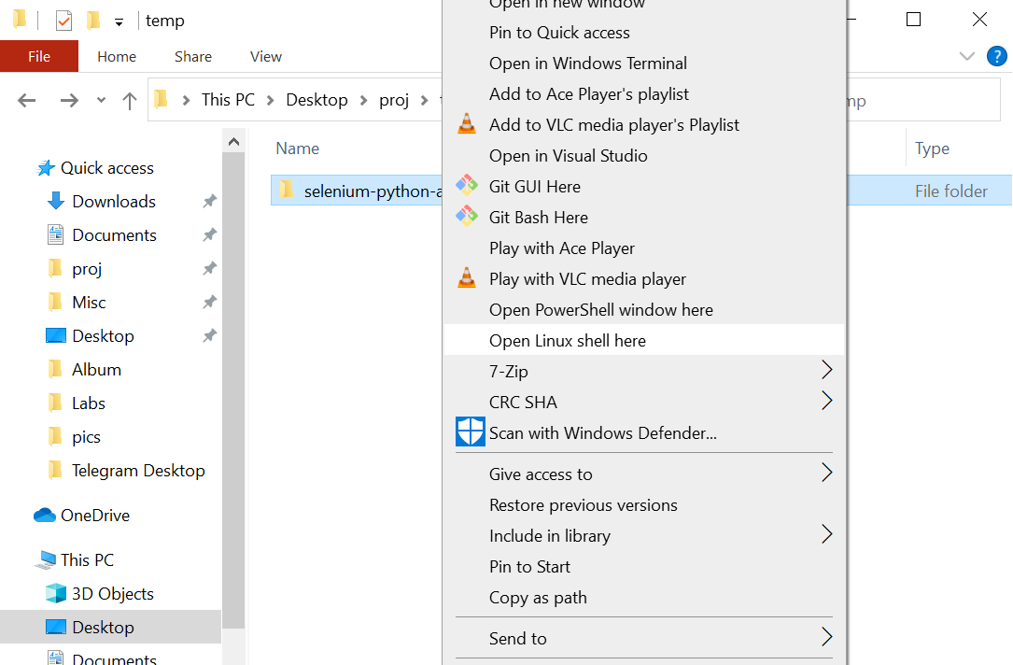

1. To upload your files to AWS Lambda, we must first zip it. To zip it, enter this command into linux terminal “zip -r lambda_function.zip *”. It will zip all the files inside the folder into a new folder called lambda_function.

You may have to first get zip so follow the prompt on the terminal which should be “sudo apt-get install zip”.

1. Follow the instructions in this article <https://medium.com/@manivannan_data/python-selenium-on-aws-lambda-b4b9de44b8e1> to set up your aws lambda function. (Key points being using python 3.6 and set environment variables PATH:/var/task/lib & PYTHONPATH:/var/task/lib)
2. To set up the trigger, select the add trigger button in the designer menu. Select EventBridge (CloudWatch Events). Then, create a new rule. You can specify how often your lambda function should be invoked. So if you want your function to be invoked every minute, select schedule expression and enter rate(1 minute). Click Add.
3. Test your function is working and check the function is triggering every X minute by checking your cloudwatch logs (which is under the Monitoring tab) at the top of the page.